- Write a shell script to print arguments passed to the script in reverse order.
Input: sh script.sh 2 5 3
Output:
3
5
2

#!/bin/bash

# get total number of arguments
count=$#

# loop from last argument to first
while [ $count -gt 0 ]
do
echo ${!count}
count=$((count-1))
done

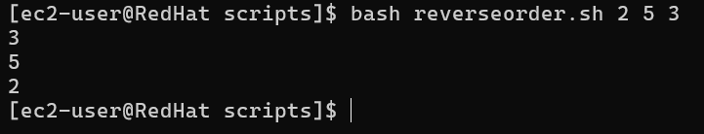

- Write a script that monitors system performance and sends a mail notification with warning messages about resource usage like ram, disk usage

Step 1 : Install Required Packages:
First, update the system and install Postfix and required dependencies.
sudo yum update -y
sudo yum install postfix postfix-lmdb s-nail cyrus-sasl cyrus-sasl-plain -y

Verify installation:
rpm -qa | grep postfix
rpm -qa | grep cyrus-sasl

- postfix → Mail Transfer Agent used to send emails
- postfix-lmdb → High-performance database backend for Postfix
- s-nail → Command-line mail client
- cyrus-sasl → Provides authentication support
- cyrus-sasl-plain → Enables plain authentication mechanism

Step 2 : Start and Enable Postfix Service
Check Postfix service status:
systemctl status postfix

If not running, start and enable it:
sudo systemctl start postfix
sudo systemctl enable postfix

Verify logs:
sudo tail -f /var/log/maillog

Step 3 : Test Gmail SMTP Connectivity
Install telnet:
sudo yum install telnet -y
Test SMTP connection:
telnet smtp.gmail.com 587
Expected output:
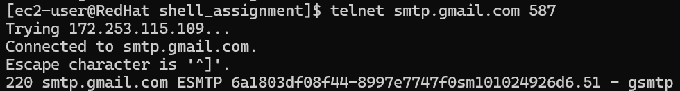

Step 4 : Backup Original Configuration
Backup Postfix configuration file:
sudo cp /etc/postfix/main.cf /etc/postfix/main.cf.backup
ls -l /etc/postfix/main.cf*

Step 5 : Create Gmail Authentication File
Create credential file:
sudo vi /etc/postfix/sasl_passwd

Add your Gmail credentials:
[smtp.gmail.com]:587 your-email@gmail.com:your_app_password

Set permissions:
sudo chmod 600 /etc/postfix/sasl_passwd

Create database file:
sudo postmap lmdb:/etc/postfix/sasl_passwd

Step 6 : Configure Postfix Main Configuration
Edit main configuration file:
sudo vi /etc/postfix/main.cf

Add the following lines:
relayhost = [smtp.gmail.com]:587
smtp_use_tls = yes
smtp_sasl_auth_enable = yes
smtp_sasl_security_options = noanonymous
smtp_sasl_password_maps = lmdb:/etc/postfix/sasl_passwd
smtp_tls_CAfile = /etc/pki/tls/certs/ca-bundle.crt

- relayhost → Specifies Gmail SMTP server
- smtp_use_tls → Enables encryption
- smtp_sasl_auth_enable → Enables authentication
- smtp_sasl_password_maps → Specifies credential file
- smtp_tls_CAfile → Specifies trusted certificate authorities

Step 7: Restart and Enable Postfix
Restart and Enable service:
sudo systemctl restart postfix
sudo systemctl enable postfix

Check status:
sudo systemctl status postfix

Verify configuration:
sudo postconf -n

#!/bin/bash

cpu_ug=$(mpstat 1 1 | awk '/Average:/ {printf("%.0f", 100 - $NF)}')
mem_ug=$(free | awk '/Mem/ {printf("%.0f", $3/$2 * 100)}')
dsk_ug=$(df / | awk 'NR==2 {print $5}' | sed 's/%//g')

logfile="/home/ec2-user/resources_alert.log"
mailid="devivaraprasadg2020@gmail.com"

for res_typ in CPU RAM Disk
do
case $res_typ in
CPU) res=$cpu_ug;;
RAM) res=$mem_ug;;
Disk) res=$dsk_ug;;
esac

if (($res >= 60))
then
echo "$res_typ usage $res% reached above threshold" >> $logfile
echo "$res_typ usage $res% reached above threshold"
tail -n 10 $logfile | mail -s "Resource Alert !!" "$mailid"
else
echo "$res_typ usage $res% resource in good condition" >> $logfile
echo "$res_typ usage $res% resource in good condition"
fi
done

Output:-

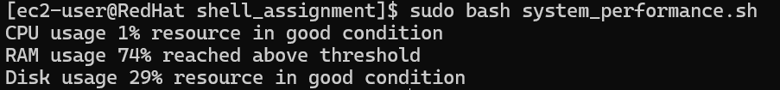

Mail received on reached above threshold:
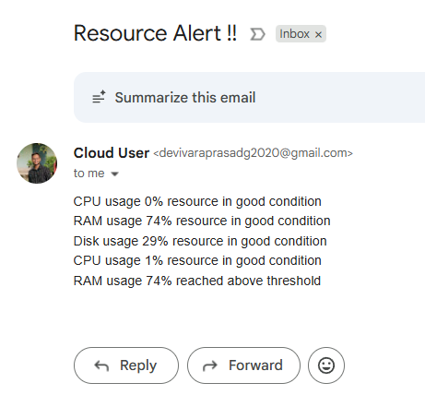
- Write a script to find the files in a directory that were last modified more than 4 weeks ago[For Practise use Mins/Days] and delete them, starting with the ones that consume the most space.

#!/bin/bash

DIR="/home/ec2-user/shell_assignment/logs"

# find files older than 28 days, sort by size, and delete
find "$DIR" -type f -mtime +28 -exec ls -lh {} + | sort -k5 -hr | awk '{print $9}' | while read file
do
echo "Deleting $file"
rm "$file"
done

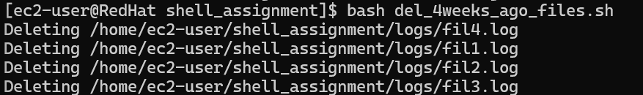

- Explain the difference between running a script with './script' and running it with 'nohup ./script &'.
#!/bin/bash
echo "Script started"
sleep 30
echo "Script finished"

- Running a script using ./script :
- Executes script in foreground
- Terminal remains busy until execution completes
- Script stops if terminal is closed
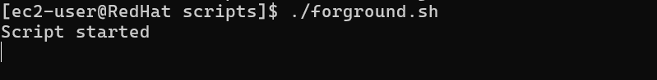
- Running a script using nohup ./script & :
- Executes script in background
- Terminal remains free for other commands
- Script continues running even if terminal is closed
- Output is stored in nohup.out file
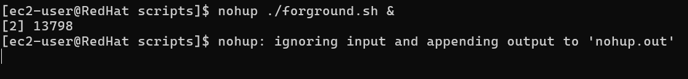
Output of nohup.out file :-
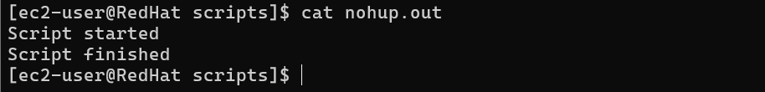
- Read an integer 'n' and generate the following

pattern:
1
1 2
1 2 3
1 2 3 4
1 2 3 4 5
up to 'n' rows.
#!/bin/bash

echo "Enter a number:"
read n

for ((i=1; i<=n; i++))
do
for ((j=1; j<=i; j++))
do
echo -n "$j "
done
echo
done
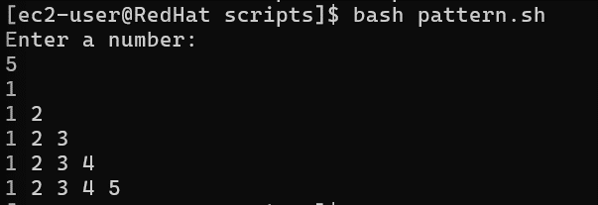
- Write a script to display the contents of the file in reverse order without using tac command
#!/bin/bash

echo "Enter filename:"
read file

lines=$(wc -l < "$file")

while [ $lines -gt 0 ]
do
sed -n "${lines}p" "$file"
lines=$((lines-1))
done

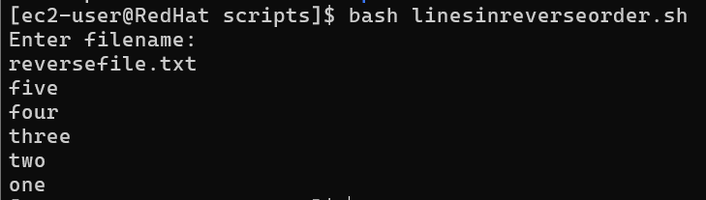

- Write a script to reverse a string using while loop
Input: hello
Output: olleh

#!/bin/bash

echo "Enter a string:"
read str

len=${#str}
rev=""

while [ $len -gt 0 ]
do
char=${str:$((len-1)):1}
rev="$rev$char"
len=$((len-1))
done

echo "Reversed string: $rev"

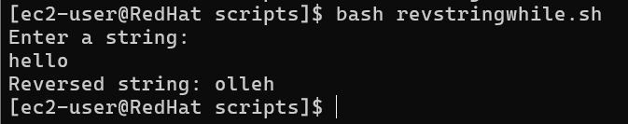

- Read an integer 'n' and generate the following
pattern:
1
2 3
4 5 6
7 8 9 10
up to 'n' rows."

#!/bin/bash

echo "Enter number of rows:"
read n

num=1

for ((i=1; i<=n; i++))
do
for ((j=1; j<=i; j++))
do
echo -n "$num "
num=$((num+1))
done
echo
done

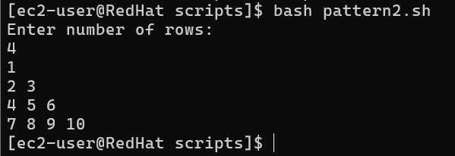

- Write a script that renames a file or directory by replacing its letters with lowercase from uppercase letters.
Example: TEst.txt → test.txt

#!/bin/bash

echo "Enter file or directory name:"
read name

lower=$(echo "$name" | tr 'A-Z' 'a-z')

mv "$name" "$lower"

echo "Renamed to: $lower"

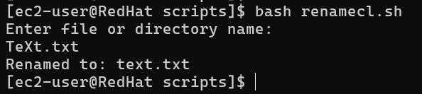

- Write a script that takes multiple inputs from the user as arguments and only prints the arguments if they are integers
Input: sh script.sh abc 2 t5 4 efg ghi 34 67 1 2
Output
The integer arguments are:
2
4
34
67
1
2

#!/bin/bash

echo "The integer arguments are:"

for arg in "$@"
do
if [[ $arg =~ ^[0-9]+$ ]]
then
echo "$arg"
fi
done

